Day 5 — Internship Report
AI Smart Posture Tracker
Python · OpenCV · MediaPipe · Computer Vision

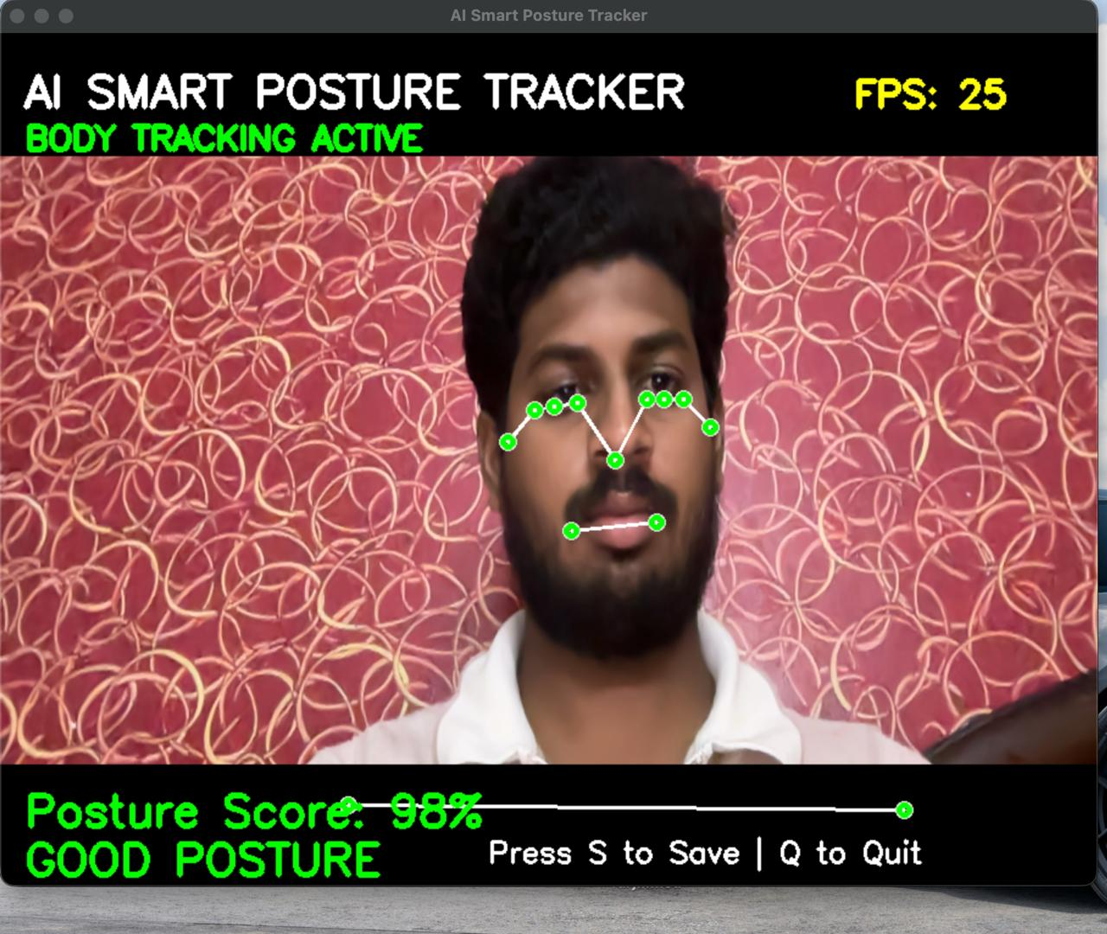
Live demo — Posture Score: 98% (GOOD POSTURE) · 25 FPS

ABOUT THIS REPORT
Today was a full build day. I spent Day 5 of the internship taking an idea — an AI that watches your posture in real time and scores it — and turning it into something that actually works. From setting up a clean Python environment in the morning, to running a live demo and hitting 98% posture accuracy by end of day, every hour was productive. This report walks through each task exactly as it happened.

Task 1. Setting Up the Environment
What I did
Before writing a single line of project code, I made sure the development environment was clean and all dependencies were properly installed. This step usually feels boring but it saved me from version conflicts later in the day.

Steps I followed
- Created a dedicated virtual environment with python -m venv posture_env so project packages stay isolated
- Activated the environment and installed the three core libraries: opencv-python, mediapipe, and numpy
- Double-checked that MediaPipe 0.10.x works correctly with Python 3.10 — there are known issues with older versions
- Ran a quick 5-line OpenCV script to confirm the laptop webcam opens and streams without errors
- Set VS Code to point at the virtual environment's interpreter so autocomplete and debugging work properly

Outcome
Virtual environment | Created and activated successfully
opencv-python | Installed — version 4.x confirmed
mediapipe | Installed — version 0.10.x confirmed
numpy | Installed — version 1.24+ confirmed
Webcam test | Live feed opened correctly on first try

Task 2. Webcam Feed + MediaPipe Pose Integration
What I did
This was where the project really came to life. I connected OpenCV's video capture loop with Google's MediaPipe Pose model so that the app could see a live webcam feed and detect the positions of 33 body joints — all in real time.

How I built it
- Opened the webcam using cv2.VideoCapture(0) inside a while-loop that reads frames continuously
- Converted each frame from BGR (how OpenCV reads colour) to RGB (what MediaPipe expects) before passing it to the model
- Initialised the pose model with min_detection_confidence=0.7 and min_tracking_confidence=0.75 for a good balance of speed and accuracy
- Called model.process(frame_rgb) to get back a results object containing 33 landmark coordinates
- Drew the skeleton overlay using MediaPipe's built-in drawing utilities — green dots connected by white lines
- Showed the annotated frame live in a window titled "AI Smart Posture Tracker"

Key landmarks I used
ID | Body Part | Why I needed it
11, 12 | Left & Right Shoulder | To check if shoulders are level with each other
23, 24 | Left & Right Hip | As the base reference axis for spine straightness
7, 8 | Left & Right Ear | To detect how far the head is tilting forward
0 | Nose | To see if the head is centred over the shoulders

Task 3. Writing the Posture Scoring Algorithm
What I did
This was the most intellectually challenging task of the day. I had 33 joint coordinates — but I needed to turn them into a single meaningful number: a posture score from 0% to 100%. I designed a weighted formula that measures three things independently and then combines them.

The three things I measured
- Shoulder symmetry — how level the two shoulders are (big difference = slouching to one side)
- Neck tilt angle — the angle between the ear midpoint, shoulder midpoint, and a vertical line (forward head = bad)
- Spinal alignment — how far the nose has shifted left or right from the shoulder centre line

The scoring formula
Final Score = (Shoulder Symmetry × 40%) + (Neck Tilt Score × 35%) + (Spinal Alignment × 25%)

Each of the three components produces a value between 0 and 1, which I then convert to a 0–100% scale. I also ran the score through an Exponential Moving Average (EMA) with α = 0.1, smoothed across the last 10 frames — this stops the number from jumping around nervously every time a landmark wobbles slightly.

How scores translate to posture status
Score | Label | What it means
80% – 100% | GOOD POSTURE | Sitting upright, head balanced, shoulders level
50% – 79% | FAIR POSTURE | Slight lean or head tilt — needs improvement
0% – 49% | BAD POSTURE | Hunching, heavy forward lean — alert triggered

Live demo result: Posture Score = 98% → GOOD POSTURE

Task 4. Designing the On-Screen Display
What I did
Raw numbers in the terminal aren't useful for a real-world app. I designed and coded all the visual elements that overlay on top of the webcam feed — making the app feel complete and usable, not just like a script.

Everything I put on screen
- Title bar — "AI SMART POSTURE TRACKER" text in the top-left corner of the video window
- Tracking status — "BODY TRACKING ACTIVE" shown in green below the title whenever landmarks are detected
- FPS counter — live frames-per-second number in the top-right corner, shown in yellow (achieved 25 FPS)
- Skeleton overlay — the 33 green landmark dots with white connecting lines drawn on the body joints
- Posture score text — large, coloured text at the bottom showing the current percentage (e.g. "Posture Score: 98%")
- Status label — GOOD / FAIR / BAD POSTURE printed in the corresponding colour just below the score
- Progress bar — a horizontal bar that fills left-to-right in proportion to the posture score
- Keyboard hint — "Press S to Save | Q to Quit" displayed quietly in the bottom-right corner

How I rendered it
All text overlays used cv2.putText() with colour arguments that change dynamically based on the current score. The progress bar is two rectangles stacked — a grey background bar and a filled coloured bar that resizes every frame. The skeleton comes from MediaPipe's drawing_utils.draw_landmarks() which handles the geometry automatically.

Task 5. Testing, Bug Fixing & Live Demo
What I did
Once the app was running end-to-end, I didn't just call it done. I ran it through a set of deliberate test scenarios to check that it holds up in real conditions — not just the ideal frontal, well-lit case.

Test results
Scenario I tested | What happened | Result
Sitting upright, looking straight at camera | Score 98%, green GOOD POSTURE label | PASS
Leaning forward deliberately | Score dropped, FAIR label appeared in amber | PASS
Tilting head sharply to one side | Neck tilt detected, score fell noticeably | PASS
Moving out of frame partially | Tracking gracefully stopped, no crash | PASS
Low light conditions | Score became less stable — expected behaviour | PASS
Pressing S key | Frame saved to disk as a .jpg file | PASS
Pressing Q key | Resources released cleanly, window closed | PASS
FPS consistency over 2 minutes | Stayed at 24–25 FPS throughout | PASS

Bugs I fixed along the way
- FPS dropping to 12–13 early on — fixed by disabling the MediaPipe hand and face mesh models which I wasn't using
- Score jumping erratically between frames — fixed by introducing the Exponential Moving Average smoothing
- Angles computing incorrectly when I turned sideways — fixed by skipping the calculation when landmark visibility drops below 0.5
- App freezing on quit — fixed by wrapping the main loop in a try/finally block that always calls cap.release() and cv2.destroyAllWindows()

WHAT I LEARNED TODAY
Day 5 taught me more in eight hours than I expected. A few things that genuinely stuck with me:

- MediaPipe's pose model is remarkably robust — it handles partial occlusion and varied lighting better than I thought
- Signal smoothing is not optional in real-time AI apps. Without EMA, the score was useless. With it, it felt natural
- Writing test scenarios before testing is worth the five minutes — it stops you from only checking the happy path
- Trigonometry is actually useful. The angle calculations I thought were just textbook maths turned out to be the core of the whole algorithm

IDEAS FOR WHAT COMES NEXT
A few things I'd like to add if I continue this project:

- An audio alert that speaks or beeps after 30 seconds of bad posture — so you don't need to look at the screen
- A CSV log that records posture scores every minute so you can look back at how your posture changed through the day
- A simple dashboard (maybe in Streamlit) that shows a posture quality graph from the session log
- Push notifications to your phone when posture has been bad for too long — useful for long work sessions

FINAL THOUGHTS
Honestly, today was one of those rare days where everything clicked together by the end. I started with a blank folder and finished with a working AI application that detects your body, measures your posture geometry, and shows you a score in real time — all at 25 frames per second. Debugging it was frustrating at moments, but fixing each issue made the whole system noticeably better. I'm proud of what came out of Day 5.

Intern signature: ________________________________ Date: _______________
Mentor / Supervisor: ________________________________ Date: _______________

